**Microprocessor Systems and Interfacing**

MINI PROJECT 1



|  |  |
| --- | --- |
| Group Members Name & Reg #: | **Muhammad Haris Irfan**  **(FA18-BCE-090)** |
|  |  |
| Class | Microprocessor Systems and Interfacing CPE342 (**BCE-6B**) |
| Instructor’s Name | Dr. Omer Ahmed |

**Mini Project 1:**

* **Task 1: Controlling a 7-Segment display using a single I/O pin**

**Project Description**

1. In this Project, I used 3 pins of the Microcontroller, one to send data (one bit at a time) and the other two pins as control pins. (as latch and clock).

2. To do this, I used an IC 74HC595, which is a shift register, this IC takes serial input and gives parallel output, I have used this phenomenon to my advantage here by sending data serially bitwise.

3. The IC works on the following principle:

1. Clock and Latch are initially set to low.
2. Clock is set to high.
3. Serial data is set to DS of IC.
4. Clock is set to Low
5. After 8 iterations when all 8 bits are set on parallel output of IC, then Latch is set to high, this shows the data on the seven segment that is connected.

4. As we have to repeat digits 0-9, so I have made a nested loop, the outer loop runs from 0-9 (the digits) and the inner loop runs from 0-7.(checking all 8 bits)

**Problems faced while Implementation**

I faced problems while writing the code, needed accuracy when setting latch to high and when to change state of clock.

Initially I was setting latch high after every bit which was not giving me my desired result then I saw some YouTube videos which explained the working of Shift register IC and that helped.

The implementation on breadboard was easy.

**Research**

When I searched internet, I came across this shift register IC. I saw videos and read some articles explaining its working, then I started working on writing a suitable code that works on my simulation.

**Used Components:**

|  |  |  |
| --- | --- | --- |
| **Sno** | **Name** | **Quantity** |
| 1 | 7 Segment Common Anode | 1 |
| 2 | Resistor 100Ohm | 8 |
| 3 | Arduino Uno | 1 |
| 4 | Connecting Wires | 11 |
| 5 | 74HC595 IC | 1 |
| 5 | Bread board | 1 |

**Reference Links**

<https://www.youtube.com/watch?v=hvxCP2Q6jN8>

https://www.arduino.cc/en/Tutorial/Foundations/ShiftOut

https://lastminuteengineers.com/74hc595-shift-register-arduino-tutorial/

**Simulation Design:**

The complete Simulation file in included in the folder.

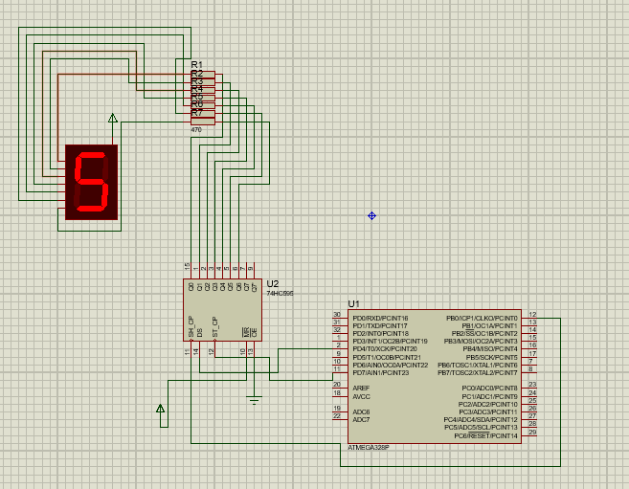

**Video:**

Video of hardware included in the folder

**____________________**

**Task 2: Controlling four 7-segment displays using a single data bus**

**Project Description**

1. In this Project, I again used 3 pins of the Microcontroller, one to send data (one bit at a time) and the other two pins as control pins. (as latch and clock).

2. In this task I used the Serial output pin of 74HC595 IC, I gave a 32-bit binary code as serial input to the first IC connected with one 7 segment, and I connected the serial output of first IC with the Serial input (DS) of second, and serial output of second with the serial input of third and serial out put of third with serial input of fourth.

3. How this worked is that each shift register has 8 bit parallel output pins, if the bits exceed 8 bits, the most significant bit is available at the serial output pin. Hence, I made full use of this and used only 1 data pin to control all four 7 segments.

4. I made the Clock and Latch pin common as data is being inputted through one pin only.

5. The IC works on the same principle as given above:

a) Clock and Latch are initially set to low.

1. lock is set to high.
2. Serial data is set to DS of IC.
3. Clock is set to Low

**Problems faced while Implementation**

I first made the simulation using 4 input data (DS) pins. One for each IC to input 4 different numbers, but then later on I discovered that IC had a feature of serial output, then I implemented this and made changes to my code.

Initially I faced problems while making a path on Veroboard, I wasted a lot of solding wire to make some paths, later we were shown a way in class which helped a lot. I exactly followed that way of using wires to connect the components and after a few hours of making and verifying connections I was finally successful at making a working hardware.

**Research**

Reading about this shift register helped a lot as otherwise I wouldn’t have come across this serial output pin.

**Reference Links**

<https://www.youtube.com/watch?v=hvxCP2Q6jN8>

https://www.arduino.cc/en/Tutorial/Foundations/ShiftOut

https://lastminuteengineers.com/74hc595-shift-register-arduino-tutorial/

**Used Components:**

|  |  |  |
| --- | --- | --- |
| **Sno** | **Name** | **Quantity** |
| 1 | 7 Segment Common Anode | 4 |
| 2 | 16-Pin IC base | 4 |
| 3 | Female to Male Headers | 10 |
| 4 | Connecting Wires | 4m |
| 5 | On- Off Button | 1 |
| 6 | 74HC595 IC | 4 |
| 7 | Veroboard Single sided | 1 |

**Simulation Design:**

The complete Simulation file in included in the folder.

**Video:**

Video of hardware and video of solding included in the folder.

**____________________**